MSU Extension’s Six-Step Community Change Model
Step 4: Gather Resources

Step 4 Guide: Gather Resources
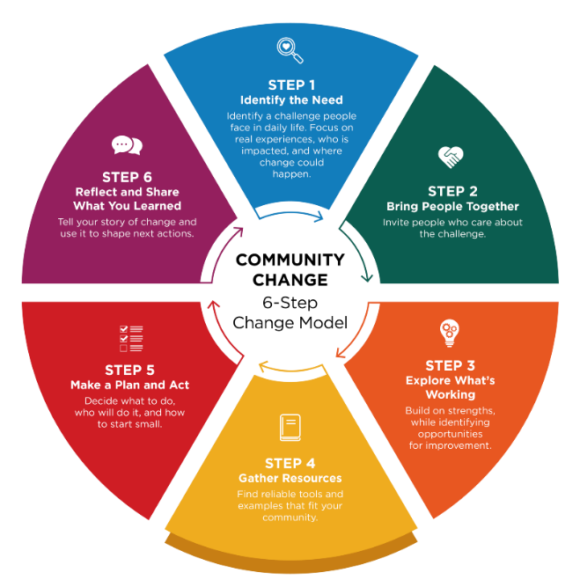
Community Champions often know partners and are passionate about choosing practical strategies that fit the community.

Once you have explored what is working and what could be better, the next step is to decide what your group wants to do. Work together to choose realistic goal(s) and gather information that can help you reach it.

Look for reliable ideas and examples

Start by reviewing trustworthy resources, practical strategies, and real‑world examples. Talk with your group about tools or ideas that could move your goal forward. Ask if anyone knows another place — or a person — who has tried something similar.

You may also want to:
- Visit communities or sites that have used successful approaches
- Connect with community champions who have done similar change work
- Observe what makes their approach effective

Seeing what others have tried can spark ideas and help you understand what might work in your setting.

Use trusted sources

When reviewing online materials, look for resources that highlight research or evidence‑based practices. Reliable, evidence-based information often comes from:

- Universities
- Professional organizations
- Government (.gov) sites

These sources can help you build a stronger, more informed plan.

Talk with your team about what fits best

Discuss what strategies feel like a good match for your group’s goals and readiness. Partners may know about resources that:

- Describe promising or evidence‑based strategies
- Provide funding or financial support
- Help plan or carry out the work

Choose options that feel realistic and doable for your group.

Questions to consider

As your group begins planning, the following questions can help clarify what’s required and where to focus your efforts. Ask:
- What does the group want to change?
- What resources are needed for success?
- Will financial support be needed?

Tip: Consider using a facilitator

It may be helpful to invite an outside facilitator for your first meeting. A trained facilitator can guide the conversation, help generate ideas, identify challenges, and make sure all voices are heard—especially when the group has diverse needs. MSU Extension does support community groups through visioning and action planning.

Step 4 Worksheet: Gather Resources (Start to Build a Plan)

Choose strategies that fit your setting and identify tools/partners to support action. Champions help determine fit, connect to resources, and communicate the plan.

1) What kind of change are you trying to make?

Choose one or more that apply. This helps identify strategies that last.

- Change the rules or expectations (guidelines/standard practices)
- Change the routine (schedules, workflows, checklists, or meetings)
- Change the space or what’s available (supplies, signage, room setup)
- Not sure yet

2) Decide on ONE clear goal to focus on first.

Goal: ____________________________________________________________________________

3) Explore what works

Review the suggested examples and strategies provided in the Community Change Hub Champion Early Health, Champion School Wellness, Champion Food Access, or Champion Active Communities.
Idea 1: ___________________________________________________________________________
Why it fits: ________________________________________________________________________
Idea 2: ___________________________________________________________________________
Why it fits: ________________________________________________________________________

4) What barriers might get in the way?

- Time
- Space
- Staffing
- Money
- Buy-in
- Knowledge/skills
- Other: ___________________________

5) Choose ONE resource from step 3 to guide your next step

Resource name: ___________________________________________________________________
What you plan to use from it: _________________________________________________________
Look for (what you plan to click/use): ___________________________________________________

Reflection

- Are there barriers to moving forward such as readiness, time, money, people you have at the table? If yes, should you identify a different goal?
- Do your resources support moving forward?

About MSU Extension’s Community Change Model
This Guide and Worksheet is part of a larger Six-Step Community Change Model Toolkit that assists community champions in supporting communities to make thoughtful, lasting improvements that help people choose nourishing foods and stay active. Six simple steps guide desired change efforts by bringing people together, taking action, and sharing what was learned along the way.
See MSU Extension’s Community Change Hub for curated resources and topic-specific guidance that support change efforts related to championing school wellness, food access, early childhood health, and active communities.

